**Decentralized Staking and AI-Powered Game Ecosystem**

**White Paper**

**Table of Contents:**

1. Abstract
2. Executive Summary
3. Problem Statement
4. Problems in Traditional Platforms
5. Our Solution (Unique Selling Proposition)
6. Key Features
7. Architecture
8. Game Overview
9. Technology Stack
10. Security and Compliance
11. Conclusion

# Abstract

Dephium introduces a revolutionary decentralized staking platform where users can stake Alephium (ALPH) tokens in interactive games and earn rewards based on their performance. By combining blockchain transparency with AI-driven mechanics, Dephium ensures a secure, trustless, and entertaining experience for participants. The platform leverages advanced AI technologies and Alephium's scalable blockchain to redefine staking and engagement through gamified scenarios and contests.

# Executive Summary

Dephium is a decentralized application (DApp) that transforms traditional staking into an interactive and rewarding gaming experience. Participants can stake ALPH tokens in two innovative game formats:

1. **SpongeBob's Cat Meme Review**: Upload and rate cat memes while competing against AI ratings inspired by SpongeBob SquarePants characters.
2. **Survival Situations**: Submit strategies to randomized survival scenarios, evaluated by advanced AI for survival probability.

Both games are underpinned by smart contracts, ensuring fair play and transparent rewards distribution. By integrating blockchain technology and AI, Dephium creates a unique ecosystem where participants enjoy transparency, security, and engagement.

# Problem Statement

Traditional staking mechanisms often lack user engagement, with rewards tied solely to the staking period and token quantity. This passive model limits user interaction and broader community engagement. Additionally:

Existing staking platforms often operate in opaque environments.

Users have limited avenues to combine staking with entertainment or skill-based rewards.

Dephium addresses these challenges by offering a gamified staking solution where rewards depend on skill and strategy, fostering an active and involved community.

# Problems in Traditional Platforms

Presence of Centralized Intermediaries**:** Traditional platforms rely on centralized servers, making user data susceptible to security breaches and unauthorized access.

Data Privacy Concerns**:** Storing sensitive user information in centralized databases exposes users to privacy risks, including potential data leaks and identity theft.

Less Secure**:** Centralized systems are more vulnerable to cyberattacks, raising concerns about the safety of financial transactions and personal information.

Limited Payment Options**:** Traditional platforms primarily support fiat currency payments, excluding the growing number of crypto users who seek alternative payment methods.

# Our Solution (Unique Selling Proposition)

Dephium transforms staking into a dynamic and interactive experience. Users stake ALPH tokens in games where their performance determines their rewards. The integration of AI ensures unbiased evaluations, while the blockchain guarantees transparency in transactions and outcomes.

Game-Driven Staking: Users stake tokens in games designed for entertainment and challenge.

AI-Powered Judging: LangChain-powered AI systems evaluate user inputs, ensuring consistency and fairness.

Decentralized Rewards: Rewards are distributed transparently through smart contracts.

# Key Features

• Seamless Wallet Integration: Connect Alephium wallets to stake tokens securely.

• Secure Staking Mechanism: Stake ALPH tokens via robust smart contracts.

• AI Integration: Advanced AI evaluates user inputs in games, ensuring unbiased results.

• Transparent Ecosystem: Blockchain records all outcomes and transactions, providing immutable proof of fairness.

# Games Overview

SpongeBob's Meme Review

Objective: Upload and rate cat memes. Compete to match AI ratings provided by the *Bikini Bottom Council*—a humorous AI ensemble inspired by SpongeBob characters.

Mechanics:

Stake ALPH tokens for each submission.

Win rewards by aligning with the AI's consensus ratings.

Survival Situations

Objective: Face randomized survival scenarios and submit strategies.

Mechanics:

AI evaluates survival probability based on creativity, logic, and feasibility.

Stake ALPH tokens on the likelihood of your success.

Rewards are determined by the accuracy of the AI's assessment.

# Technology Stack

Frontend: React 18, TypeScript, and Vite for a dynamic and responsive user interface.

UI Framework: TailwindCSS and ShadcnUI for sleek, user-friendly design.

AI: LangChain integrated with Google Gemini Pro for advanced natural language understanding and decision-making.

Blockchain: Alephium's scalable Web3 SDK ensures secure and efficient smart contract operations.

# Architecture

Frontend Interface: Intuitive dashboards for staking, gameplay, and reward tracking.

Smart Contracts: Secure contracts manage staking, game mechanics, and rewards distribution.

AI Integration Layer: AI evaluates meme ratings and survival strategies, leveraging real-time data for fair outcomes.

Blockchain Records: Immutable and transparent logs of staking, gameplay, and prize distribution.

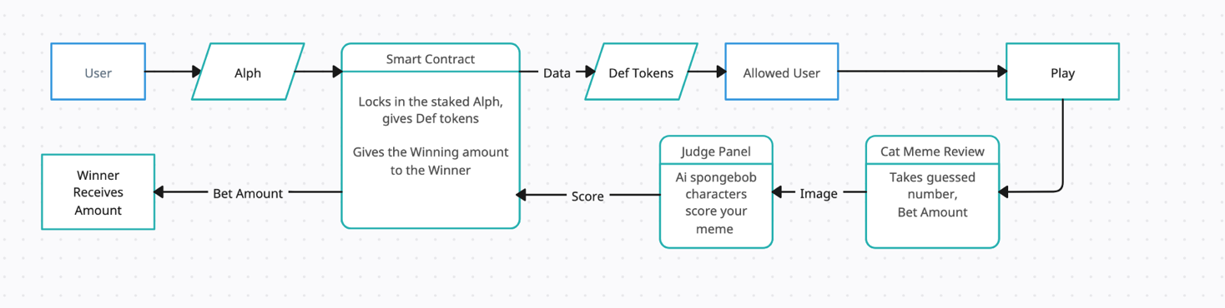

# Security and Compliance

Smart Contract Audits: Regular audits to ensure the reliability and security of staking and gameplay mechanisms.

Anti-Cheat Mechanisms: AI monitors submissions for authenticity and originality.

Compliance: Adheres to relevant jurisdictional regulations for gaming and blockchain-based staking.

# Conclusion

Dephium redefines staking by combining it with interactive and rewarding games. By integrating Alephium's secure blockchain and LangChain-powered AI, Dephium offers an engaging, fair, and transparent platform for users to stake tokens and earn rewards. With a roadmap focused on user-driven growth, Dephium is set to become a leader in decentralized gamified staking.